Resume
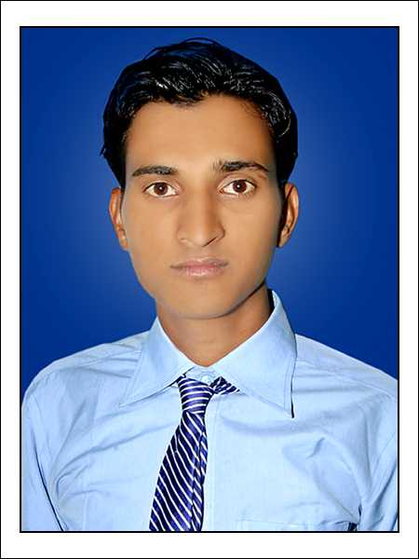
Vasim Akram
Mobile:+91 9269113788, +91 7737446112
Email: vasimraza@ymail.com

To work in a growth oriented organization where my intellect and management skills will be utilized towards continuous growth and advancement of self and the organization.
PROFESSIONAL SNAPSHOT
- Master of Business Administration(Marketing & Information Technology )
- Bachelor of Computer Application
- Management Trainee
Philips india limited 45days
Key Responsibilities:
- Market Research. Of Lighting (CFL,LED ,Panel,light,Outdoor light)
- Finding out market share of the organization.by Dealer And Distributior
- Find Project sales and close Deal
- Management Trainee
Snapdeal India 45days
Key Responsibilities:
- Market Research For Snapdeal
- Finding out E-ccommerce market share of the organization.

ACADEMIC CREDENTIALS
Master of Business Administration

    - Completed MBA (Marketing & IT) in 2013 with 70 .00 % from Vyas Institute of Managament, Jodhpur , affiliated to (Rajasthan Technical University) Kota(Rajasthan)

    - Completed BCA in 2011 with 69 .23 % from Govt. Bangur PG college Pali, Affiliated to( MDS University Ajmer.(Rajasthan)

Sr. Secondary
- Completed In 2008 with 62.31% from Board of Secondary Education, Ajmer(Rajasthan)

Experience & Services
- 1 Year (Sep10 To Agust 11 work in Videocon Ltd. As a (Customer care officer ,Jodhpur Pali jalor.Sirohi(Rajasthan)
Role & Responsibility-
- All Videocon Group company
- (Videcon,Sansui,Hundai,Akai,kelvinator,kenstar )
- Team Handling of 12 Engneer team With Four Districts (Jodhpur pali Jalor Sirohi)
- Product (LED ,REF,AC.TV,Microwave,Air coller Etc)

- Work in Ujala Sales Pvt. Ltd.(Machinery,Appliances,Pump, Handling chain Managment Dealer And Distributer ) From March 13 to sep14 As a Area sales Executive jodhpur (Pali, Sirohi, Jalor)
Role & Responsibility:-
- Handing Distributer & Dealer Retailer
- Project sales Handling with sales Team
- Responsibility Sales in Jodhpur ( pali Jalor Sirohi)
- Product (Electric machine,MonoBlock Pump,Sumersible,Fan,Gyeser, Appliances,Wire ,MCB Etc)

- Work in Arise india Ltd.(Machinery,Appliances,Pump, Handling Chain Managment Distributer ,Manpower With Retailer & Dealer ) From sep14 to parsent As a Area Sales Manager ,Jodhpur (Pali, Sirohi, Jalor)
Role & Responsibilitiy-
- Handling Distributer & Dealer Retailer
- Responsibility Sales (Jodhpur pali Jalor Sirohi)
- Handling Team of Sales Executive
- Product (Electric Machine, MonoBlockPump,Sumersible,Fan,Gyeser, Appliances Etc)

Skills & Abilities

- Powerful Leadership & Management skills along.

- Good Communication Skills

- Team /People handling abilities.

- Excellent knowledge of Computer.

- Excellent knowledge in Marketing/ Service

PERSONAL DETAILS

Date of Birth : 7th December, 1990

Address : 106, Shiv Nagar Mandia Road Pali (Rajasthan)

Languages Known : English, Hindi Urdu, Arabic(Read)And Regional

Father’s Name : Mr. Manfool Chouhan

Mother’s Name : Mrs. Rabbiya Bano

Marital Status : Single

Passport No : K3395823(valid Till 2022)

DECLARATION

I, Vasim Akram hereby declare that the above provided information is true to the best of my knowledge and belief. The relevant credentials would be given whenever required.

Vasim akram

